Contents
Preface
Document Conventions
Glossary Conventions
1. Accessing the Admin Web Portal
Logging in to the Web Portal
Understanding the Admin Portal Interface
2. Quick Guide to Common Tasks
Resetting a Password
Replacing Employees
Moving a Phone
Changing Open Hours
Setting New Holidays
Setting Call Forwarding
Blocking a Caller
3. Working with Active Calls
Call Graphs
Statistics Panel
4. Working with Users
Displaying the Users Page
Adding Users
Editing Users
Configuring the User Profile
Configuring User Answering Rules
Allowing or Blocking Calls
Adding Answering Rules
Changing the Active Answering Rule
Editing Answering Rules
Deleting Answering Rules
Configuring User Voice mail
Configuring Phones
Associating Phones with This User
Editing Phones
Deleting Phones
Importing Users
Deleting Users
5. Working with Conferences
Displaying the Conferences Page
Adding Conferences
Editing Conferences
Deleting Conferences
Joining a Conference
Viewing Conference Statistics
6. Working with Automated Attendants
Displaying the Auto Attendants Page
Adding Auto Attendants
Recording Intro Greetings and Menu Prompts
Editing Auto Attendants
Deleting Auto Attendants
Auto Attendant Best Practices
7. Working with Call Queues
Displaying the Call Queues Page
Adding Call Queues
Editing Call Queues
Deleting Call Queues
Adding Music on Hold to a Queue
Working with Agents
8. Working with Time Frames
Displaying the Time Frames Page
Working with Time Frames
Adding Time Frames
Editing Time Frames
Deleting Time Frames
Viewing Begin and End Dates
9. Working with Music On Hold
Displaying the Music On Hold Page
Adding Music On Hold Files
Changing the Order of Music On Hold Files
Editing Music On Hold Files
Deleting Music On Hold Files
Adjusting Music On Hold Settings
10. Working with Inventory
Displaying the Inventory Page
Managing Phone Numbers
Filtering Phone Numbers
Editing Phone Numbers
Exporting Phone Numbers
Managing Phone Hardware
Filtering Phone Hardware
Adding Phones
Editing Phones
Exporting Phone Hardware Information
11. Viewing Call History
Displaying the Call History Page
Filtering Call History
Exporting Call History
12. Taking a Phone Home
Installing a Phone at Home
Troubleshooting a Remote Phone
Appendix A. Glossary
Index

Preface
Welcome to the ParagonVoIP WEB Centrex Administrator’s Guide. Your ParagonVoIP WEB Centrex system includes a comprehensive set of administrator tools for configuring and managing the system. This guide describes how to use these features to optimize your ParagonVoIP WEB Centrex experience.
Document Conventions
This guide uses the following conventions to draw your attention to certain information.

Convention | Description
Note | Notes emphasize or supplement important points of the main text.
Bold |  | Indicates text on a window, other than the window title, including menus, menu options, buttons, fields, and labels.
Italic |  | Indicates a variable, which is a placeholder for actual text provided by the user or system. Angled brackets (< >) are also used to indicate variables.
screen/code |  | Indicates text that is displayed on screen or entered by the user.
Glossary Conventions
The first time a technical term is used in this guide, it appears as a hyperlink. Clicking the link in the electronic version of this document takes you to the Glossary where the term is defined. Clicking the term in the Glossary returns you to the first instance of the term.

Accessing the Admin Web Portal
Topics: |  | All administrator tasks are performed from the admin portal. The admin portal is a web-based application that runs on any device (mobile phone, tablet, or PC) running a browser.  You access the admin portal using the user portal login. After logging in to the user portal, users with admin permission can access the admin portal.
- Logging in to the Web Portal (page )
- Understanding the Admin Portal Interface (page )

.

Logging in to the Web Portal
To log in to the web portal:
- Launch a web browser.
- In the browser address bar, type the supplied portal Uniform Resource Locator (URL) and press the Enter key. The Login page appears.

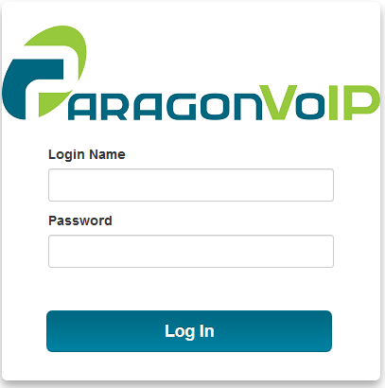

- At the Login page, enter the login name ext@customerdomain.com, where customerdomain.com typically is the same as your email address domain. Then enter your password. For security, each typed password character is masked by a dot (●).
- Click Log In.
- At the top-right of the page, click the Manage Organization link.
Note: If the Manage Organization link does not appear, you do not have Office Manager permissions.

Click this link.

Understanding the Admin Portal Interface
The top of the admin portal interface contains a menu bar with icons for navigating through the portal (see Table ‎1-1). When you click an icon, the page associated with the icon appears in the dashboard. Some pages have tabs for accessing configuration settings.
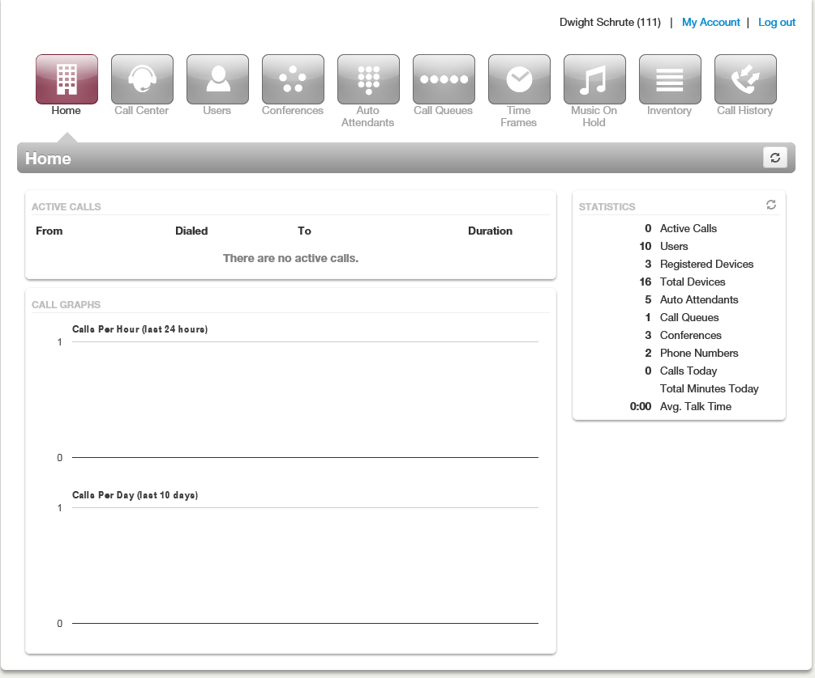
User name, Account, and Log out links
Menu bar
Dashboard

Table ‎1-1. Admin Menu Icons
Menu Icon | Description | See Chapter
 | Shows active call information such as graphs and statistics. | ‎3
 | Shows users configured in the system, and allows you to add, edit, and import users. | ‎4
 | Shows conferences configured in the system, and allows you to edit, delete, join a conference, and view conference statistics. | ‎5
 | Shows auto attendants configured in the system, and allows you to add, edit, and delete auto attendants. | ‎6
 | Shows call queues configured in the system, and allows you to add, edit, and delete call queues, add Music On Hold files to call queues, and configure agents associated with call queues. | ‎7
 | Shows all time frames configured in the system, and allows you to add, edit, and delete time frames and view time frame start and end times. | ‎8
 | Shows all files that are part of the Music On Hold feature, and allows you to add, edit, and delete Music on Hold files, change the order in which files are played, and randomize the playing of the files. | ‎9
 | Allows you to manage the phone numbers and phone hardware in the system. | ‎10
 | Allows you to review, filter, and export call logs for greater analysis. | ‎11

Quick Guide to Common Tasks
Topics: |  | This chapter describes frequently performed tasks.
- Resetting a Password (page )
- Replacing Employees (page )
- Moving a Phone (page )
- Changing Open Hours (page )
- Setting New Holidays (page )
- Setting Call Forwarding (page )
- Blocking a Caller (page )

Resetting a Password
- On the menu bar, click .
- Click the name of the user that needs a password change.
- Scroll down to the Change Password section, and then enter a new numeric password in the New Password and Confirm New Password fields.
- Click Save.

Replacing Employees
If you have a new employee taking over an old employee’s extension:
- On the menu bar, click .
- Click the name of the user being replaced.
- Change the name, department, email address, and password, as appropriate, and then click Save.
- To reset the mailbox for the new employee, click the Voicemail tab, scroll down to the Data section, click Clear Data followed by Yes at the confirmation prompt, and then click Save.

Moving a Phone
If a user changes offices, we recommend moving the phone. The user’s extension will follow the phone. Otherwise, use the following procedure to reassign phones:
- On the menu bar, click .
- Click the Phone Hardware tab.
- Click the MAC address of the appropriate phone.
- In the pop-up window, reassign the extensions, and then click Save.

Changing Open Hours
- On the menu bar, click .
- Click the name of the time frame you want to edit.
- In the pop-up window, change the When setting. Use the check boxes, sliders, and text fields to adjust the open hours rules, as appropriate.
- Click Save.

Setting New Holidays
Setting new holidays is a 2-step procedure. First, create or edit a time frame, and then configure user answering rules for that time frame.
- Set the time frame:
- On the menu bar, click .
- Click Add Time Frame to add a new time frame or click the Name of the time frame you want to edit.
- In the pop-up window, enter or edit the name for the holiday, click when it occurs, and use the check boxes, sliders, and text fields to adjust the rules, as appropriate.
- Click Save.
- Set the user answering rules:
- On the menu bar, click .
- Click the Name of a user who needs the time frame applied to him.
- Click the Answering Rules link.
- Check to see whether the time frame already applies to that user. Otherwise click Add Rule.
- Using the Time Frame drop-down list, select the time frame you defined in step 1.
- Complete the other settings as appropriate (see
- Table ‎4-2 on page ).
- Click Save.
- Reorder the time frames as needed to ensure the new rule will take precedence.

Setting Call Forwarding
- On the menu bar, click .
- Click the name of the user you want to forward.
- Click the Answering Rules tab.
- Hover over a time frame, and then click the icon.
- In the pop-up window, select the appropriate call forwarding check box and enter the extension, number, or phone.
Note: Your main number usually is associated with a user called the “Inbound Route.” For more information about Call Forwarding, see “Adding Answering Rules” on page .

- Click Save.

Blocking a Caller
- On the menu bar, click .
- Click the name of the user that needs a block. To block a caller from the main number, look for the Inbound Route user.
- Click the Answering Rules tab.
- Click the Allow/Block button.
- In the pop-up window, enter the caller’s number under BLOCKED NUMBERS, and then click +.
- Click Done.

Working with Active Calls
Topics: |  | The Home page has an ACTIVE CALLS section that shows graphical and statistical information about current calls. This information updates automatically as active calls change.
- Call Graphs (page )
- Statistics Panel (page )

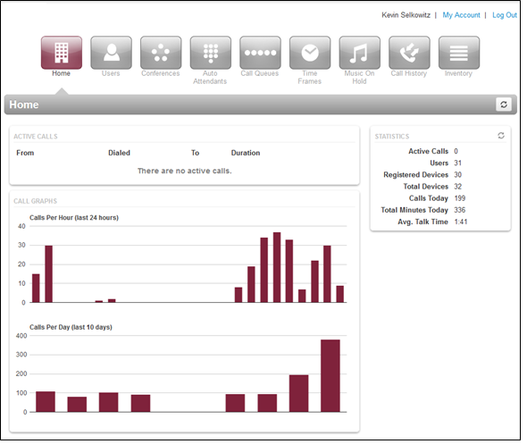
Active Calls Page

Call Graphs
The left side of the Home page shows call graphs. These graphs display calls by hour and day, allowing you to see trends in system usage. For more information about call details, see “Viewing Call History” on page .

Statistics Panel
The right side of the Active Calls page has a Statistics panel that shows the status and activity of the system, as described in the following table. The button at the top-right side of the panel allows you to update the statistics shown.
Statistics | Description
Active Calls | Number of calls that are currently active.
Users | Number of users on the system.
Registered Devices | Number of phones that are currently operational.
Total Devices | Total number of devices configured on your system.
Auto Attendants | Total number of auto attendants in the system.
Call Queues | Total number of call queues in the system.
Conferences | Total number of conferences in the system.
Phone Numbers | Number of phone numbers assigned to your system.
Calls Today | Number of calls dialed and received today.
Total Minutes Today | Total amount of talk time.
Avg. Talk Time | Average talk time per call.

Working with Users
Topics: |  | Users are the extensions on your system. This chapter describes how to add, edit, and import users to the system. System users are users associated with queues, auto attendants, and other system features.
- Displaying the Users Page (page )
- Adding Users (page )
- Editing Users (page )
- Importing Users (page )
- Deleting Users (page )

Displaying the Users Page
All user tasks are performed from the Users page. To display this page, click the Users icon on the menu bar:
The following figure shows an example of the Users page.

A search field at the top-left of the page allows you to search users by entering their name, extension, or department, and then clicking the magnifying glass icon:
To sort users by name, extension, or department, click a blue column header. The arrow next to column header shows whether the items are sorted in ascending (up arrow) or descending (down arrow) order.
The button at the top-right side of the page refreshes the information on the page.
The bottom-left side of the page has controls to display the next or previous page. The bottom-right side has controls to hide system users and select the number of users shown per page.
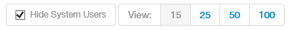

Where to go from here: | From the Users page, you can:  - Add users. See “Adding Users” on page .  - Edit users. See “Editing Users” on page .  - Import users. See “Importing Users” on page .  - Delete users. See “Deleting Users” on page .

Adding Users
- From the Users page, click the Add User button. An Add a User pop-up window similar to the following appears. (The options in your window might differ from the ones shown below.)

- Complete the fields (see Table ‎4-1).
- Click Add User.
Table ‎4-1. Adding/Editing a User
Setting | Description
First Name | Enter the user’s first name. The dial-by-name directory can match on this field, but will by default match Last Name.
Last Name | Enter the user’s last name. The dial-by-name directory can match on this field.
Extension | Enter the user’s extension.
Department | Enter the department to which the user belongs.
Timezone | Enter the user’s time zone.
Email Address(es) | Enter the user’s address used for email, password resets, etc. To add email addresses, click the green plus icon.
User’s Scope | Select the user’s access level. Choices are the following (your selections might be different):  - Basic user  - Office manager  - Call center agent (may not appear in your drop-down list)  - Call center supervisor (may not appear in your drop-down list)
Enable Voicemail | Enable or disable voicemail. Choices are:  - Checked = enable voicemail.  - Not checked = disable voicemail.
Add Phone Extension | This setting allows you to add a phone extension. Phone extensions allow users to be associated with a phone. A user can have one or more phone extensions. For example, user 111 could have three phones designated as 111a, 111b, and 111c. If you check this check box, you can then associate a phone to the user (see Table ‎10-3 on page ). Choices are:  - Checked = add phone extension.  - Not checked = do not add phone extension.
New Password | Enter a new numeric login password for the user. For security, each typed password character is masked by a dot (●).
Confirm New Password | Enter the same numeric login password you entered in the New Password field. For security, each typed password character is masked by a dot (●).

Editing Users
There might be times when you need to edit users. For example, you might need to change names, passwords, answering rules, voice mail, or phone settings.
- From the Users page, either:
- Click a name
OR
- Hover over a user name, click the icon at the far right of the Users page, and then click Profile. For example:

…click this icon and…
…click this selection
Click a name or… icon

Where to go from here: | When a page similar to the following appears, use the tabs to configure the settings for this user:  - Use the Profile tab to configure profile, caller ID, dial planning, and login password for the selected user. See “Configuring the User Profile” on page .  - Use the Answering Rules tab to configure time frames and answering rules for the selected user. See “Configuring User Answering Rules” on page .  - Use the Voicemail tab to configure voicemail settings for the selected user. See “Configuring User Voice mail” on page .  - Use the Phones tab to configure the phones associated with the selected user. See “Configuring Phones” on page .

Configuring the User Profile
To configure the profile for the selected user, complete the fields in the Profile tab, and then click Save.
Note: The options in your tab might be different than the ones shown below.

Setting | Description
Profile Information
First Name | Enter the user’s first name.
Last Name | Enter the user’s last name. The user’s last name is particularly important for the dial-by-name directory, as it matches on this field.
Login Name | Read-only field that shows the login name this user uses to log in to the portal.
Department | Enter the department to which the user belongs.
Timezone | Enter the user’s time zone.
Email Address(es) | Enter the user’s address used for email, password resets, etc. To add email addresses, click the green plus icon.
Record User’s Calls | Select whether the calls for this user will be recorded (Yes) or not recorded (No).
Directory Options | Enables or disables announce in auto directory and list in directory features.  - Announce in Audio directory = check to include the user in the dial-by-name directory.  - List in Directory = check to add user to the internal extensions list (contacts).
Caller ID Information
Area Code | Area code associated with the user.
Caller ID | Caller ID numbers that will be displayed for this user.
911 Caller ID | Caller ID number sent when calling 911. This may be different than your regular caller ID.
Dial Planning
Dial Permission | Select the dialing permissions for the user.
Change Password
New Password | Enter a new numeric login password for the user. For security, each typed password character is masked by a dot (●).
Confirm New Password | Enter the same numeric login password you entered in the New Password field. For security, each typed password character is masked by a dot (●).

Configuring User Answering Rules
Answering rules define how calls to this extension are handled. To configure answering rules for the selected user:
- From the Users page, click the Answering Rules tab. A page similar to the following appears.
- Use the Ring for drop-down list to select the maximum number of seconds that incoming calls ring for this user before the system routes the call to the user’s voicemail or the Forward if Unanswered option, if configured.
- From this page, you can:
- Allow or block calls for this user (see “Allowing or Blocking Calls” on page ).
- Add answering rules for this user (see “Adding Answering Rules” on page ).
- Change the active rule for this user (see “Changing the Active Answering Rule” on page ).
- Edit answering rules for this user (see “Editing Answering Rule” on page ).
- Deleting answering rules for this user (see “Deleting Answering Rules” on page ).

Allowing or Blocking Calls
To allow or block calls for this user:
- Click the Allow/Block button. The Allow/Block pop-up window appears.

- Calls from allowed numbers bypass call screening and server side Do Not Disturb (not phone DND). To allow numbers for this user, enter a number in the Enter a number field under ALLOWED NUMBERS, and then click the plus sign next to this field. Repeat this step for each additional number you want to allow for this user.
- Calls from blocked numbers receive a fast busy or number disconnected message. To block numbers for this user, enter a number in the Enter a number field under BLOCKED NUMBERS, and then click the plus sign next to this field. Repeat this step for each additional number you want to block for this user.
- To block anonymous or unknown numbers, check Block anonymous or unknown.
- Click Done.

Adding Answering Rules
Adding additional answering rules allows you specify alternate call answering rules in a different time frame (for example, handle calls differently on a weekend than on a weekday). To add an answering rule for this user:
- Click the Add Rule button. The Add an Answering Rule pop-up window appears.

- Complete the settings in the Add an Answering Rule pop-up window.

Table ‎4-2. Adding/Editing Answering Rules
Setting | Description
Time Frame | Select a time frame to which this answering rule will be applied. Choices shown are the ones previously configured using the procedure under “Adding Time Frames” on page .
Enabled | Add an answering rule: this check box does not appear.  Edit an answering rule: enable (check) or disable (uncheck) this time frame for this user.
Do not disturb | Enables or disables the Do Not Disturb feature. Choices are:  - Checked = enable Do Not Disturb. Send all calls directly to voicemail (if available), without ringing the phone.  - Not checked = disable Do Not Disturb.
Call screening | Enables or disables the Call Screening feature. Choices are:  - Checked = enable Call Screening. System prompts callers to say their name, and then lets you screen the call before accepting it.  - Not checked = disable Call Screening.
Call Forwarding options | Select the following appropriate Call Forwarding settings. When entering another extension as a Call Forward option, a drop-down menu allows you to forward the call to specific resources associated with that extension (see Table ‎4-3). Some settings might not appear, depending on the features associated with the given extension.  Choices are:  - Always = immediately forward calls to the number specified in the text field.  - When busy = forward calls to the number specified in the text field when your extension has used all available call paths.  - When unanswered = forward calls to the number specified in the text field if the call is not answered after the specified ring timeout.  - When offline = automatically forward calls to the number specified in the text field if your desk phone has lost communication (for example, during a power outage).
Simultaneous Ring | Simultaneous ring allows multiple phones to ring at the same time. Check boxes allow you to include the user’s extension, ring all user phones at the same time, and use answer confirmation for offnet numbers.  - Include user’s extension = check to ring the phone with the same extension as the user.  - Ring all user’s phones = ring all phones associated with this user at the same time.  - Answer confirmation for offnet numbers = ensures when conducting a simring to a cell/landline that the answering party is a person instead of voicemail by requesting them to press 1 to accept the call.
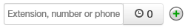 | In this field, you can enter the extension of another telephone you want to ring.  The clock icon allows you to specify a ring delay. A ring delay allows you to enter the amount of time before the call rings at the destination. To add other phones to the simring, click the green plus icon.
Just ring user’s extension | Enables or disables the ringing of your telephone only.  - Checked = incoming call rings just your telephone.  - Not checked = feature is disabled.

Table ‎4-3. Call Forward Selections
Selection | Description
User | Forward calls to the user at the specified extension and follow their user-answering rules.
Handset | Bypass the user-answering rules and forward calls to the handset associated with the specified user.
Voicemail | Forward calls to voicemail at the specified extension.
Queue | Forward calls to the queue associated with this user.
Auto Attendant | Forward calls to the auto-attendant associated with this user.

- Click Save.
- Repeat this procedure to add answering rules for this user.

Changing the Active Answering Rule
You can define multiple answering rules, but only one rule can be active at a time. The active rule is the first rule with a matching time frame. Best practices dictate that you order answering rules according to how specific they are, with the most specific time frames (for example, Holidays) at the top.
Assume today is Monday, July 4th. In this example, the Holidays and Open time frames could match the time and date conditions for July 4th. If Holidays is the first rule, however, it becomes the active rule. But if Open is the first rule, Open becomes the active rule.
To specify a rule other than the top one as the active rule:
- In the Answering Rules tab, find the rule you want to designate as the active rule.
- On the left side of the Answering Rules tab, hover the mouse over the up/down arrows for that rule (the pointer changes to a 4-headed arrow).
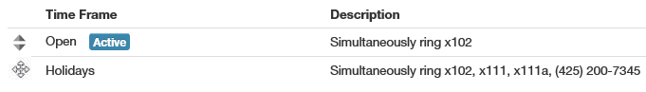

Pointer is hovering here

- Hold down your mouse button, drag the rule to the top row, and then release the mouse button. A message tells you that the answering rules have been reprioritized and prompts you to click Save.

Message that active rule has been reprioritized
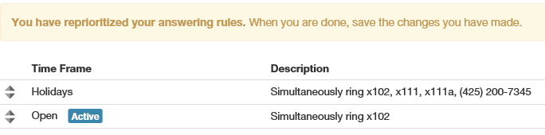

- Click Save. The Active designation appears next to the topmost time frame.
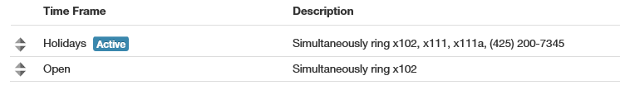

Editing Answering Rules
To edit an answering rule for this user:
- In the Answering Rules tab, hover over the answering rule, and then click the icon at the far right of the row.

Click this icon
The Edit Answering Rule pop-up window appears.
- Change the rule, as appropriate. For assistance, see Table ‎4-2 on page .
- Click Save.

Deleting Answering Rules
If you no longer need an answering rule for a user, you can delete the rule. You can delete any answering rule, except the default rule.
- In the Answering Rules tab, hover over the answering rule, and then click the icon at the far right of the row.

Click this icon
A confirmation prompt appears.
- Click Yes to delete the rule or No to retain it.

Configuring User Voice mail
To configure voice mail for the selected user:
- From the Users page, click the Voicemail tab. A page similar to the following appears.

- Complete the settings in the Voicemail tab.

Table ‎4-4. Voicemail Settings
Setting | Description
Enable | Enable (check) or disable (uncheck) voicemail.
Inbox
Options | This setting affects audio voicemail (calling into voicemail), but does not affect the web portal voice messages. Check the appropriate inbox options. Choices are:  - Sort Voicemail inbox by latest first = plays newest messages first.  - Announce voicemail received time = plays the timestamp of the message.  - Announce incoming call ID = plays the caller ID number if available.
Operator Forward | This setting determines where a call is sent if the caller presses 0 while the voicemail greeting is being played. When using this feature, tell callers near the beginning of your recorded voicemail greeting that they can press 0 to redirect their call.
Number of Messages | Read-only field that shows the current count of messages. Click the Clear messages link to delete messages, but leave greetings in place.
Data
Limit | Read-only field that shows user’s storage limit.
Used | Read-only field that shows user’s used storage. Click the Clear data link to delete all messages, greetings, and the name recording.
Greetings
Voicemail Greeting | To select an active voicemail greeting, click a greeting from the drop-down list.  To play the selected greeting, click the icon.  To download the selected greeting, click the icon.  To upload or record a greeting, click the icon to display the Manage Greetings pop-up window. Greetings must be in MP3 or WAV format.  To upload a greeting:  - Next to New Greeting, click Upload.  - Use the Browse button to select the file.  - In the Greeting Name field, enter a name for the greeting.  - Click Save and Done.  To record a greeting:  - Next to New Greeting, click Record.  - In the Call me field, enter number to call (either an extension or a telephone number such as your cell phone).  - In the Greeting Name field, enter a name for the greeting.  - Click Call. Your phone will be called. At the prompt, record the new greeting, and then press # when you finish your recording.  - Click Done. (Or click Add Greeting to add another greeting.)
Recorded Name | If your company has a dial-by-name directory, you must record your name to appear in the directory. Click the icon to listen to your current name recording on your computer or click the icon to upload or record a new greeting.
Unified Messaging
Email Notification | Adjust your voicemail to email settings. Choices are:  - None = no emails when voicemail is left.  - Send w/ Hyperlink = system sends an email to this user with a link to the voicemail  - Send w/ Brief Hyperlink = system sends an email to this user in plaintext with a link to the voicemail  - Send w/ Attachment (storage option) = system sends an email to this user with the audio file of the message attached. The storage option lets this user leave messages in his inbox as new, move to saved, or move to trash.  - Send w/ Brief Attachment (storage option) = system sends an email to this user in plaintext with the audio file of the message attached. The storage option lets this user leave messages in his inbox as new, move to saved, or move to trash.
Options | Check the appropriate unified messaging options. Choices are:  - Send email when inbox is full = system sends an email if this user’s voice mail inbox runs out of space.  - Send email after missed call = system sends an email if this user missed a call.

- Click Save.

Configuring Phones
To associate phones with the selected user:
- From the Users page, click the Phones tab. A page similar to the following appears.
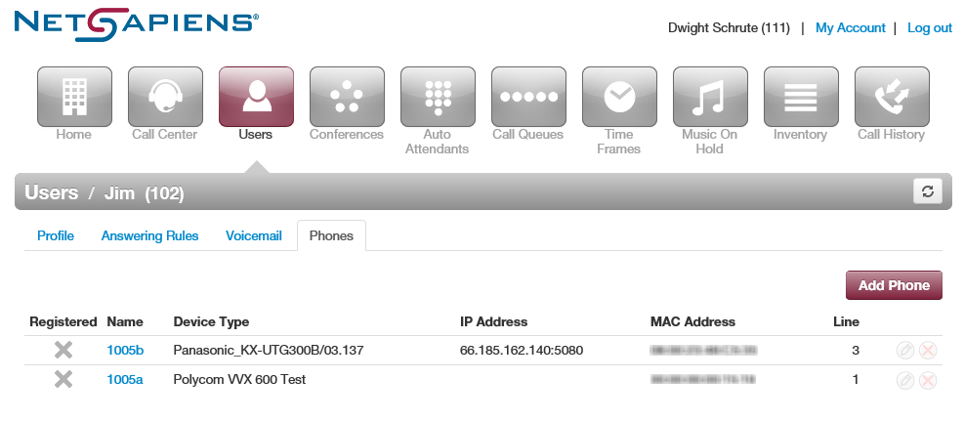

Where to go from here: | From the Phones tab, you can:  - Associate a phone with this user (see “Associating Phones with This User” on page ).  - Edit phones associated with this user (see “Editing Phones” on page ).  - Delete phones associated with this user (see “Deleting Phones” on page ).

Associating Phones with This User
To associate phones with this user:
- Click the Add Phone button. The Add a Phone pop-up window appears.
- Complete the settings in the Add a Phone pop-up window.
Table ‎4-5. Adding/Editing Phones
Setting | Description
Phone Name | Adding a phone: Enter a name for this phone. The name should allow you to differentiate this phone from other phones you associated. For example, if you add phones for x111, you can name them 111a, 111b, and so on.  Editing a phone: read-only field that shows the name of the phone.
Record Calls | Select whether calls will be recorded (Yes) or not recorded (No).
Model | Select the telephone model. The remaining settings in the window change depending on the model selected.
Preferred Server | Select the preferred server with which the phone will be used.

- Click Add.
- Repeat this procedure to associate additional phones with this user.
- After you configure all phones, reboot the phones to apply these settings.

Editing Phones
To edit a phone associated with this user:
- From the Phones tab, either:
- Click a name
OR
- Hover over a name, and then click the icon at the far right of the page. For example:

…click this icon
Click a name or… icon

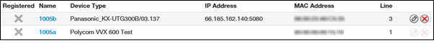
Either step displays the Edit Phone pop-up window.
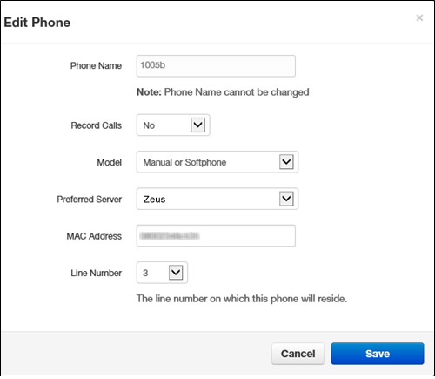
- Change the phone settings, as appropriate. For assistance, see Table ‎4-5 on page .
- Click Save.

Deleting Phones
If you no longer need a phone that is associated with this user, you can delete the phone.
- In the Phones tab, hover over the phone, and then click the icon at the far right of the row. A confirmation prompt appears.
- Click Yes to delete the phone or No to retain it.

Click this icon

Importing Users
A quick way to add users into the system is by importing them. The system accepts users in comma-separated-value (CSV) format. As part of this procedure, you can download a CSV-formatted template that can be opened using Microsoft Excel, populate the template with users, and then import the template.
- From the Users page, click the Import button. The Import Users pop-up window appears.
- To download a template that you can populate and import into the system:
- Click the Download Template button.
- Save the template to an area you can access.
- Open the template, populate it with users, and then save the template.
- Click the Browse button, navigate to the location where the file containing the users to be imported is located, click the file, and then click Open.
- Click Upload. The system shows a preview of the data to be imported and allows you to edit the values if needed.

Deleting Users
If you no longer need a user, you can delete the user from the system.
- From the Users page, hover over the user, and then click the icon at the far right of the row. A confirmation prompt appears.
- Click Yes to delete the user or No to retain it.

Click this icon
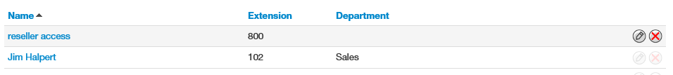

Working with Conferences
Topics: |  | Your ParagonVoIP WEB Centrex system includes a conference bridge that allows people inside and outside your company to participate in a conference call.
- Displaying the Conferences Page (page )
- Adding Conferences (page )
- Editing Conferences (page )
- Deleting Conferences (page )
- Joining a Conference (page )
- Viewing Conference Statistics (page )

Displaying the Conferences Page
All conference tasks are performed from the Conferences page. To display this page, click the Conference icon on the menu bar:
The following figure shows an example of the Conferences page. The button at the top-right side of the page refreshes the information on the page.

Where to go from here: | From the Conferences page, you can:  - Add conferences. See “Adding Conferences” on page .  - Edit conferences. See “Editing Conferences” on page .  - Delete conferences. See “Deleting Conferences” on page .  - Join a conference. See “Joining a Conference” on page .  - View conference statistics. See “Viewing Conference Statistics” on page .

Adding Conferences
The following procedure describes how to add conferences. When adding a conference, we recommend you require a leader to start the conference; otherwise, anyone with your participant code can use your bridge.
- From the Conferences page, click the Add Conference button. The Add a Conference pop-up window appears.

- Complete the fields (see Table ‎5-1).
- Click Add Conference.
Table ‎5-1. Adding/Editing a Conference
Setting | Description
Name | Enter a name for this bridge. The name should allow you to differentiate this bridge from other bridges you configured.
Type | Select the conference type. Choices are:  - Dedicated conference bridge = a shared bridge on its own dedicated extension.  - Owned conference bridge = a bridge associated to a user on the system (for example, the bridge for user 111).
Extension | Adding a conference: select the extension used to join this conference.  Editing a conference: read-only field that shows the extension.
Direct Phone Number | Select the phone number used to join the conference.  Owned bridges also have a direct dial field, which is the number internal users can dial to access the bridge.
Leader PIN | Enter the personal identification number (PIN) that the leader will use to authenticate access when joining the meeting. This PIN is private and should be known by internal staff only.
Participant PIN | Enter the PIN that participants will use to authenticate access when joining the meeting. Distribute this PIN to all guests of the meeting.
Minimum participants to start | Select the minimum number of participants that must attend the conference before it can start.
Options | Select the following options:  - Require a Leader to start = when checked, the system requires a leader to start the conference. If unchecked, the conference call will start when the first participant joins, regardless of whether a leader is present.  - Prompt all participants for their name = when checked, the system prompts users for their name when they call in to the conference call.  - Announce participant arrivals/departures = when checked, the system either beeps or announces when a participant joins or leaves the conference.

- Click Save.

Editing Conferences
There might be times when you need to edit conferences. For example, you might want to change the leader or participant PIN.
- From the Conferences page, either:
- Click a name
OR
- Hover over a name, and then click the icon at the far right of the Conferences page. For example:

…click this icon
Click a name or…
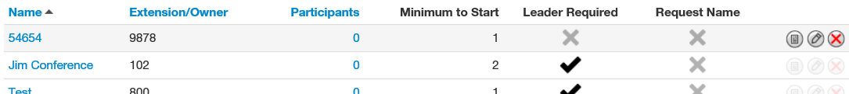

Either step displays the Edit pop-up window. For example:

- Complete the fields (see Table ‎5-1 on page ).
- Click Save.

Deleting Conferences
If you no longer need a conference, you can delete it from the system.
- From the Conferences page, hover over the conference, and then click the icon at the far right of the row. A confirmation prompt appears.
- Click Yes to delete the conference or No to retain it.

Click this icon

Joining a Conference
There are several ways to join a conference.
- Phones in your system can dial a dedicated bridge via the extension of the bridge. An owned bridge can be dialed by using the configured Direct Dial code.
- Set a Direct Inward Dial (DID) number to the bridge for inside and outside callers (see “Working with Inventory“ on page ).
- Participants can call into your main number, and then be transferred to the bridge, or the bridge can be an option of the auto attendant.
When joining, the system prompts you for your password (either the leader or participant PIN, depending on your role).

Viewing Conference Statistics
You can display historical information about your bridge.
- From the Conferences page, hover over the conference, and then click the icon at the far right of the row.

Click this icon

A pop-up window shows statistics about the selected conference.
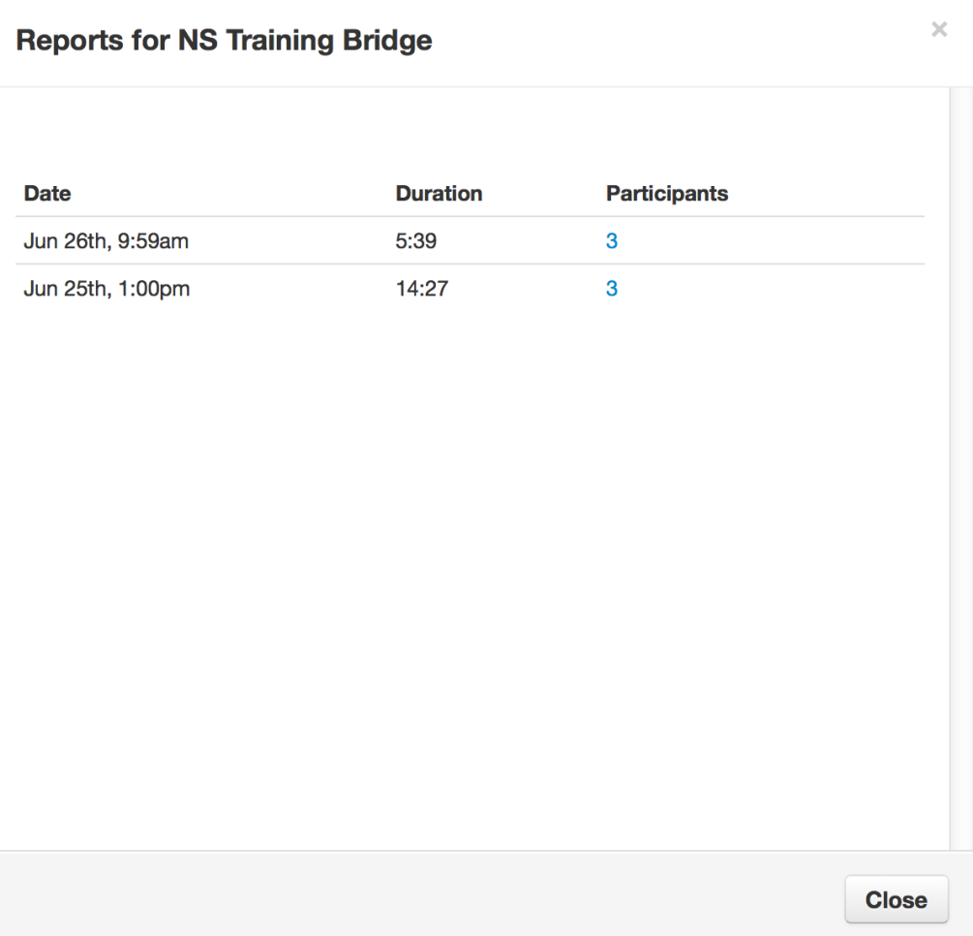
- For more information about participants, click the hyperlink under the Participants column.
- When you finish viewing the information, click Close to close the pop-up window.

Working with Automated Attendants
Topics: |  | Automated attendants (“auto attendants”) are automated greetings with options to route calls. The ParagonVoIP ParagonVoIP WEB Centrex system has an auto attendant builder that gives you easy access to change recordings and options anytime.  The Auto Attendants list displays each auto attendant. From the Auto Attendants List, you can edit auto attendant settings and record the auto attendant greeting.
- Displaying the Auto Attendants Page (page )
- Adding Auto Attendants (page )
- Editing Auto Attendants (page )
- Deleting Auto Attendants (page )
- Auto Attendant Best Practices (page )

Displaying the Auto Attendants Page
All auto attendant tasks are performed from the Auto Attendants page. To display this page, click the Auto Attendants icon on the menu bar:
The following figure shows an example of the Auto Attendants page. The button at the top-right side of the page refreshes the information on the page.

Where to go from here: | From the Auto Attendants page, you can:  - Add attendants. See “Adding Conferences” on page .  - Edit attendants. See “Editing Conferences” on page .  - Delete attendants. See “Deleting Conferences” on page .

Adding Auto Attendants
The following procedure describes how to add auto attendants.
- From the Auto Attendants page, click the Add Attendant button. The Add an Auto Attendant pop-up window appears.

- Complete the fields (see Table ‎6-1).
Table ‎6-1. Adding/Editing an Auto Attendant (Page 1)
Setting | Description
Name | Enter a name for this auto attendant. The name should allow you to differentiate this auto attendant from other auto attendants you configured.
Extension | Adding an auto attendant: select the extension used with this auto attendant.  Editing an auto attendant: read-only field that shows the extension.
Time Frame | Select a time frame to which this answering rule will be applied. Choices shown are the ones previously configured using the procedure under “Adding Time Frames” on page .

- Click Continue. A page similar to the following appears.

- Complete the fields (see Table ‎6-2).
Table ‎6-2. Adding/Editing an Auto Attendant (Page 2)
Setting | Description
Auto Attendant Name | This is the auto attendant name you entered on the previous page. Use this field to change the name if desired.
Extension | Read-only field that shows the extension associated with this auto attendant that you entered on the previous page.
Intro Greetings | Click the icon to display the Manage Greetings pop-up window and play, upload, record, or delete greetings. See “Recording Intro Greetings and Menu Prompts” on page ).
Menu Prompt | Click in the text box or click the icon to upload or record a menu prompt (see “Recording Intro Greetings and Menu Prompts” on page ).

Dial Pad Menu | Routes calls to one of a variety of resources when a caller selects that option. Click a number, and then select an application from the following pop-up:
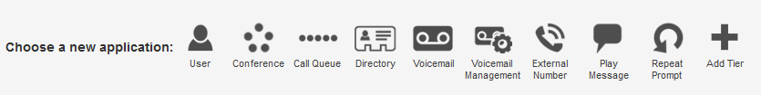
- User = goes to a user (extension).
- Conference = goes to a conference bridge.
- Call Queue = goes to a call queue.
- Directory = goes to a dial by name directory.
- Voicemail = goes to a specific mailbox.
- Voicemail Management = allows outside staff to call in and retrieve voicemail.
- External Number = forwards to an external telephone number (for example, to send caller to on-call staff).
- Play Message = commonly used for hours and directions.
- Repeat Prompt = replays the menu of options to the caller.
Add Tier = adds a submenu with a new greeting and set of options.
Options | Click this button to open a pop-up window with the following options. Click Done when finished.:  - Enable dial by extension = enable (check) or disable (uncheck) dial by extension.  - If no key is pressed = sets the default action if no key is pressed.  - If unassigned key is pressed = sets the action if an unassigned key is pressed.

- Click Save.

Recording Intro Greetings and Menu Prompts
Each auto attendant can have an optional introductory greeting that plays when a call is directed to the auto attendant followed by the menu prompt. An example of an introductory greeting might be:
"Thank you for calling Acme Corporation. You've reached us outside normal business hours."
A menu prompt might be:
“Press 1 for sales, press 2 for marketing, or press 0 for operator assistance.”
Separating intro greetings from menu prompts allows you to change greetings for holidays or night-time hours, for example, without re-recording the entire message.
To record an intro greeting:
- From Auto Attendants page, click the icon next to Intro Greetings. A Manage Greetings pop-up window similar to the following appears.
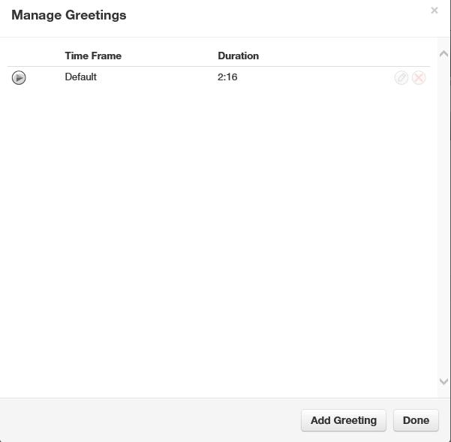

- From this pop-up window:
- To play a greeting, click the icon.
- To upload a new greeting, hover over it, and then click the icon on the right side of the row. For New Greeting, click Upload. Click the Browse button, navigate to the MP3 or WAV file you want to use for your greeting, click the file, and click Open. Click Upload.
- To record a new greeting, hover over it, and then click icon on the right side of the row. For New Greeting, click Record. In the Call me at field, enter the number to call (either an extension or a telephone number such as your cell phone) and click Call. Your phone will be called. At the prompt, record the new greeting, and then press # when you finish your recording.
- To delete a recording, hover over it, and then click the icon at the far right of the row. At confirmation prompt, click Yes to delete the recording or No to retain it.
- When you finish, click Add Greeting followed by Done.
To record a menu prompt:
- From Auto Attendants page, under Menu Prompt, click either the field Click to add a new menu prompt or click the icon next to the field. Either step displays a Manage Audio pop-up window similar to the following.
- Complete the fields (see Table ‎6-3).
Table ‎6-3. Manage Audio Settings
Setting | Description
Description | Enter a name for this greeting. The name should allow you to differentiate this greeting from other greetings you recorded.
New Greeting | Select whether to upload or record a greeting. Greetings must be in MP3 or WAV format. Choices are:  - Upload = use this option to upload a file for use as your greeting. Click the Browse button. Navigate to the file, click the file, and click Open. Click Upload.  - Record = if you select this option, enter the number to call (either an extension or a telephone number such as your cell phone) and click Call. Your phone will be called. At the prompt, record the new greeting, and then press # when you finish your recording.

- Click Save in the Manage Audio pop-up window.

Editing Auto Attendants
There might be times when you need to edit auto attendants.
- From the Auto Attendants page, either:
- Click a name
OR
- Hover over a name, and then click the icon at the far right of the Auto Attendants page. For example:

…click this icon
Click a name or… icon

Either step displays a pop-up window similar to the following.

- Complete the fields (see Table ‎6-2 on page ).
- Click Save.

Deleting Auto Attendants
If you no longer need an auto attendant, you can delete it from the system.
- From the Auto Attendants page, hover over the auto attendant, and then click the icon at the far right of the row. A confirmation prompt appears.
- Click Yes to delete the auto attendant or No to retain it.

Click this icon

Auto Attendant Best Practices
When configuring your auto attendant, observe the following best practices:
- Consider your callers. Do they know with whom they want to talk or what function they need (customer service, sales, and so on)? Taking your callers into account will help you determine how to configure your auto attendant.
- If callers know with whom they want to talk, assist them by providing options such as:
- “Dial your party’s extension at any time.”
- “Press x for a dial by name directory.”
- “Press x for the first available person/general voicemail.”
- “Press 1 for Bob, 2 for Susan,” and so on. However, this approach does not scale well.
- If callers do not know a specific person but need a function, provide options such as:
- “Press x for a dial by name directory.”
- “For sales, press 1.”
- “For customer service, press 2.”
- “For accounting, press 3.”
Keep greetings brief. Do not flood callers with too much information (hours, directions, fax numbers). Instead, place that information into a “play message” option.

Working with Call Queues
Topics: |  | Call queues are a “waiting line” commonly used for support and sales groups. Callers receive music on hold while waiting for the next available agent.
- Displaying the Call Queues Page (page )
- Adding Call Queues (page )
- Editing Call Queues (page )
- Deleting Call Queues (page )
- Adding Music On Hold Files (page )
- Working with Agents (page )

Displaying the Call Queues Page
All call queue tasks are performed from the Call Queues page. To display this page, click the Call Queues icon on the menu bar:
The following figure shows an example of the Call Queues page. The button at the top-right side of the page refreshes the information on the page.

Where to go from here: | From the Call Queues page, you can:  - Add call queues. See “Adding Call Queues” on page .  - Edit call queues. See “Editing Call Queues” on page .  - Delete call queues. See “Deleting Call Queues” on page .  - Edit Music on Hold settings. See “Adding Music on Hold” on page .  - Work with agents associated with call queues. See “Working with Agents” on page .

Adding Call Queues
To add call queues:
- From the Call Queues page, click the Add Call Queue button. The Add a Call Queue pop-up window appears, with the Basic tab displayed.

- Complete the fields (see Table ‎7-1).

Table ‎7-1. Adding/Editing Basic Call Queue Settings
Setting | Description
Name | Enter a name for this call queue. The name should allow you to differentiate this call queue from other call queues you configured.
Extension | Adding a call queue: Select an extension.  Editing a call queue: read-only field that shows the extension.
Type | Determines how calls are distributed. Choices are:  - Round robin = routes callers to the agent that has been idle for the longest period of time. Then complete the remaining fields in the window.  - Ring All = routes callers to all available agents at the same time. Then complete the remaining fields in the window.  - Linear Hunt = routes callers to the available agents in a predefined order. The order is defined when editing the queue’s agents (see “ Working with Agents” on page ). Then complete the remaining fields in the window.  - Linear Cascade = routes callers to groups of available agents in a predefined order. The order is defined when editing the queue’s agents (see “ Working with Agents” on page ). Then complete the remaining fields in the window.  - Call Park = places callers on hold until the agent retrieves them. Go to step 4.
Phone Number | Select the phone number
Record Calls | Select whether calls will be recorded (Yes) or not recorded (No) for this call queue.
Statistics | Select whether statistics will be recorded (Yes) or not recorded (No) for this call queue.
Message to Agent | Enter the message that will be sent to the agent (for example, “Here's a call from the emergency support queue.”)  You configure this setting after adding the call queue.

- For Type, if you clicked Park, click Save to complete this procedure. Otherwise, click Next to display the Pre Queue Options tab and proceed to the next step.

- Complete the fields (see Table ‎7-2).

Table ‎7-2. Adding/Editing Pre-Queue Option Settings
Setting | Description
Require agents | Select whether to require (Yes) or not require (No) agents for this call queue.
Require Intro into MOH | This setting forces playback of the complete intro MOH before dispatch. This is useful for compliance greetings such as "Calls may be recorded,” and so on. Select whether to require (Yes) or not require (No) the complete playback of the Intro Music on Hold for this call queue.
Max Expected Wait | Use the slider to specify the maximum expected wait time, in seconds. If the estimated wait time exceeds this time, the call cannot queue.
Max Queue Length | Use the slider to specify the maximum number of people that the system will allow to wait in this call queue.
Allow Callback option | This setting allows callers to record their number, hang up, keep their spot in line, then get called when an agent is available. Select whether the callback option is available (Yes) or not available (No) to users in this call queue.
Forward if unavailable | This setting specifies where to forward if prequeue options will not allow queueing (for example, expected wait is too high). Enter where the call forwards if queueing is not available.

- Click Next. The In Queue Options tab appears.

- Complete the fields (see Table ‎7-3).
Table ‎7-3. Adding/Editing In-Queue Option Settings
Setting | Description
Queue Ring Timeout | Use the slider to specify the maximum number of seconds that the call remains in the queue before timing-out. If Forward if Unanswered is enabled, the call is handled according to the Forward if Unanswered setting. If Voicemail is enabled and Forward if Unanswered is disabled, the system prompts the caller to stay in the queue or go to voicemail.
Agent Ring Timeout | Use the slider to specify the maximum number of seconds that the queue will ring an agent before moving on to the next agent. This value should be less than the Queue Ring Timeout value.
Logout agent on missed call | Select whether an agent logs callers out of the queue (Yes) or does not log out callers if an agent misses a call.
Forward if Unanswered | Enter the extension, phone, or number where callers are forwarded if agents fail to answer before the Queue Ring Timeout occurs
Voicemail | Select whether callers will be (Yes) or will not be (No) given the option to leave a voicemail if agents fail to answer when the Queue Ring Timeout occurs and Forward if unanswered is not set.

- Click Add.

Editing Call Queues
There might be times when you need to edit Call Queues. For example, you might want to change basic, pre-queue, or in-queue options.
- From the Call Queues page, either:
- Click a name
OR
- Hover over a name, and then click the icon at the far right of the Call Queues page. For example:

…click this icon
Click a name or… icon

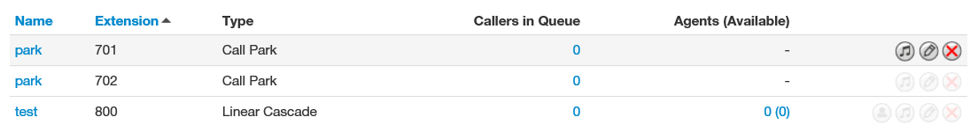

Either step displays the Edit pop-up window. For example:

- Perform the procedure starting with step 2 under “Adding Call Queues” on page .

Deleting Call Queues
If you no longer need a call queue, you can delete it from the system.
- From the Call Queues page, hover over the call queue, and then click the icon at the far right of the row. A confirmation prompt appears.
- Click Yes to delete the call queue or No to retain it.

Click this icon

Adding Music on Hold to a Queue
The Call Queues page allows you to add Music on Hold for call queues.
- From the Call Queues page, hover over the call queue, and then click the icon at the far right of the row. The Music On Hold page appears.
- Proceed to “Adding Music On Hold Files” on page .

Click this icon

Working with Agents
The Call Queues page allows you to add, edit, and delete agents for call queues.
- From the Call Queues page, hover over the call queue, and then click the icon at the far right of the row.

Click this icon
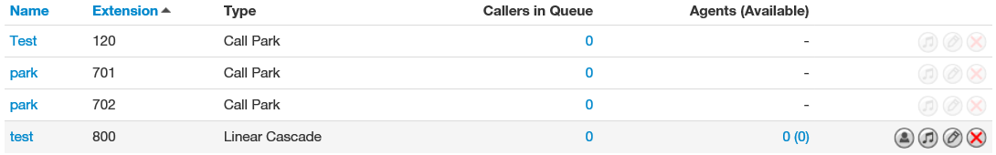

An Edit Agents pop-up window similar to the following appears.
- To add an agent:
- Click the Add Agent button. The following settings appear.

- Complete the fields (see Table ‎7-4).
- Click Save. The color-coded status of the new agent is displayed:
- Green = available
- Gray = offline
- Red = on a call
Table ‎7-4. Adding/Editing Agent Settings
Setting | Description
Agent Phone | Select a phone of an agent to add to the queue.
Status | Select whether the agent is ready to take calls (Online) or not active (Offline).
Wrap up time | Use the slider to specify the amount of time the agent is allocated to complete paperwork after finishing a call and before a new call is dispatched.
Max Simultaneous calls | Use the slider to specify the maximum number of calls an agent can take at one time. This will almost always be 1.
Order in Linear Hunt | Sets the dispatch order. If a call is dispatching, it will go to the available agent with the lowest order.
Queue priority for agent | Sets weighting for an agent that is servicing multiple queues. If you have an agent servicing two queues and both queues have a person waiting, for example, the agent will get the call from the queue whose priority is highest (lowest number).
Request Confirmation | Enables or disables request confirmation. Choices are:  - Checked = requires the agent to confirm receiving the call.  - Not checked = agent does not confirm the call.
Auto Answer | Enables or disables auto answer. Choices are:  - Checked = agent phone answers automatically (not all phones support this feature).  - Not checked = agent phone not answer automatically.

- Click Done.
- To edit agent settings:
- Hover over an agent, and then click the icon at the far right of the window. Settings similar to the following appear.

- Complete the fields (see Table ‎7-4 on page ).
- Click Save. The color-coded status of the new agent is displayed:
- Green = available
- Gray = offline
- Red = on a call
- To delete an agent:
- Hover over an agent, and then click the icon at the far right of the window.
- When a confirmation prompt appears, click Yes to delete the agent or No to retain it.
- When you finish working within the pop-up window, click Done.

Working with Time Frames
Topics: |  | Using time frames, you can tell the system about the times when your office is open, closed, or celebrating a holiday.  Time frames do not go into effect until you apply a time frame to an answering rule or auto attendant greeting. When the time frames are applied, the first matching time frame becomes active.
- Displaying the Time Frames Page (see page )
- Working with Time Frames (page )
- Adding Time Frames (page )
- Editing Time Frames (see page )
- Deleting Time Frames (see page )
- Viewing Begin and End Dates (see page )

Displaying the Time Frames Page
All time frame tasks are performed from the Time Frames page. To display this page, click the Time Frames icon on the menu bar:
The following figure shows an example of the Time Frames page.
A search field at the top-left of the page allows you to review a specific user's personal time frames by entering a user time frame, and then clicking the magnifying glass icon:
The button at the top-right side of the page refreshes the information on the page.
Where to go from here: | From the Time Frames page, you can:  - Add time frame. See “Adding Time Frames” on page .  - Edit time frames. See “Editing Time Frames” on page .  - Delete time frames. See “Deleting Time Frames” on page .  - See begin and end dates for a time frame. See “Viewing Begin and End Dates” on page .

Working with Time Frames
When you create a new time frame, you assign a unique name to it and then specify one of the following times associated with the time frame:
- Always = time frame applies to all hours of every day (24/7/365).
- Days of the week and times = commonly used to define office open hours such as Monday-Friday 9am – 5pm. Each day has its own check box. Check the days to which the time frame will be applied, and then use slide bars to define the time ranges for each checked day.
- Specific dates or range = commonly used to define holidays or other special events such as New Year’s or a training closure. Use pop-up calendars to select the To and From dates when the time range will apply.
When you check a check box, a blue control bar covers the times 9AM to 5PM for that day. Drag this control to change the time according to your requirements. If you need to add more ranges for a day, click the following icon to the right of the time range:

- Specific dates or ranges = allows you to specify a time range for the time frame by selecting starting and ending dates from a pop-up calendar.
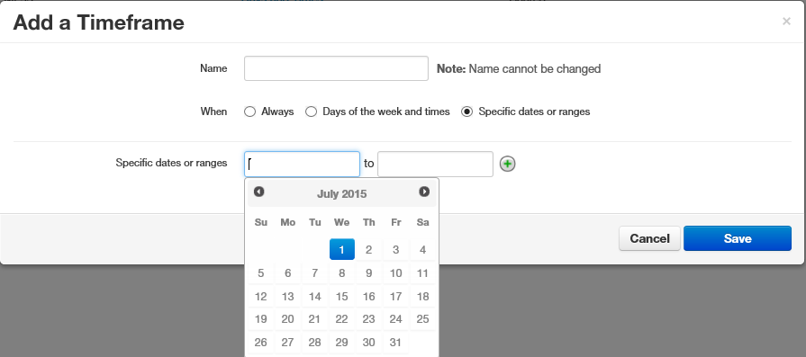

The following example shows a time frame called Open Hours, which covers 9AM to 5PM hours for the days Monday through Friday.
This time frame might be used with another time frame called Holiday, which covers holiday periods. You might even create a time frame called Closed Hours (default already exists), which would be an “Always” rule, but would not always be active since it can be set for lower priority than Holiday or Open Hours.

Adding Time Frames
To add time frames:
- From the Time Frames page, click the Add Time Frame button. The Add a Timeframe pop-up window appears.

- Complete the fields (see Table ‎8-1).
Table ‎8-1. Adding/Editing Time Frame Settings
Setting | Description
Name | Adding a time frame: Enter a name for this time frame. The name should allow you to differentiate this time frame from other time frames you configured.  Editing a time frame: read-only field that shows the name of the time frame.
When | Select when the time frame will be applied. Choices are:  - Always = time frame is applied to all days and times.  - Days of the week and times = use the controls in Figure ‎8-1 to check the days when the time frame applies, and then use the slider controls to select the hours for that date when the time frame applies.  - Specific dates or ranges = use the controls in Figure ‎8-2 to select the dates or range to which the time frame applies.

Figure ‎8-1. Configuring Days of the Week
Figure ‎8-2. Configuring Specific Dates or Ranges

- Click Save.

Editing Time Frames
There might be times when you need to edit time frames. For example, you might want to change when they occur.
- From the Time Frames page, either:
- Click a name
OR
- Hover over a name, and then click the icon at the far right of the Time Frames page. For example:

…click this icon
Click a name or… icon

Either step displays the Edit pop-up window. For example:

- Complete the fields (see Table ‎8-1 on page ).
- Click Save.

Deleting Time Frames
If you no longer need a time frame, you can delete it from the system.
- From the Time Frames page, hover over the time frame, and then click the icon at the far right of the row. A confirmation prompt appears.
- Click Yes to delete the time frame or No to retain it.

Click this icon

Viewing Begin and End Dates
To view the begin and end dates for a time frame:
- From the Time Frames page, hover over the description. A pop-up window similar to the following shows the begin and end dates for the time frame.

Hover over a description…
…to see the begin and end dates

Working with Music On Hold
Topics: |  | The system has a Music on Hold feature that plays when callers are on hold or waiting in queue. You can precede the first file with an optional introductory greeting.
- Displaying the Music On Hold Page (page )
- Adding Music On Hold (page )
- Changing the Order of Music On Hold Files (page )
- Editing Music On Hold Files (page )
- Deleting Music On Hold Files (page )
- Adjusting Music On Hold Settings (page )

Displaying the Music On Hold Page
All Music On Hold tasks are performed from the Music On Hold page. To display this page, click the Music On Hold icon on the menu bar:
The following figure shows an example of the Music On Hold page.
A search field at the top-left of the page allows you to view the MOH files for a specific user by entering a file name, and then clicking the magnifying glass icon:

The button at the top-right side of the page refreshes the information on the page.
Where to go from here: | From the Music On Hold page, you can:  - Add files. See “Adding Music On Hold” on page .  - Change the order of files. See “Changing the Order of Music On Hold Files” on page .  - Edit files. See “Editing Music On Hold Files” on page .  - Delete files. See “Deleting Music On Hold Files” on page .  - Adjust Music On Hold settings. See “Adjusting Music On Hold Settings” on page .

Adding Music On Hold Files
The following procedure describes how to add files. Only properly licensed music files can be used with the Music On Hold feature.
- From the Music On Hold page, click the Add Music button. The Add Music pop-up window appears.

- Complete the fields (see Table ‎9-1).
Table ‎9-1. Adding/Editing Music On Hold
Setting | Description
Browse | Adding a Music On Hold file: Use this button to upload a file in MP3 or WAV format. Click the Browse button. Navigate to the music file, click the file, and click Open.  Editing a Music On Hold file: this field does not appear.
Song Name | Enter a name for this file.

- Click Upload.
- After the file is uploaded, you can play it on your computer by clicking the icon to the left of the file on the Music On Hold page.

Changing the Order of Music On Hold Files
Music On Hold files play according to the order in which they appear in the Music On Hold page, starting with the top file on the page, if the randomization setting is not selected. To change the order in which files are played:
- On the left side of the Music On Hold page, hover the mouse over the up/down arrows for the file you want to move (the pointer changes to a 4-headed arrow).

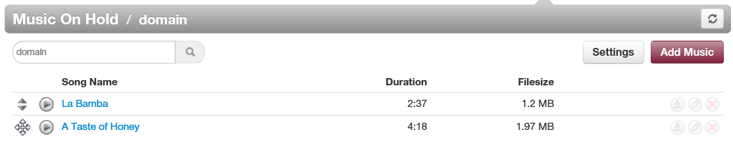

Pointer is hovering here

- Hold down your mouse button, drag the file to the desired location, and then release the mouse button. A message tells you that the file has been reprioritized and prompts you to click Save.

Message that file has been reprioritized

- Click Save.

Editing Music On Hold Files
There might be times when you need to edit the name of a Music On Hold file.
- From the Music On Hold page, either:
- Click a file name
OR
- Hover over a file name, and then click the icon at the far right of the Music On Hold page. For example:

…click this icon
Click a file name or… icon

Either step displays the Edit Music pop-up window. For example:

- Complete the field (see Table ‎9-1 on page ).
- Click Save.

Deleting Music On Hold Files
If you no longer need a Music On Hold file, you can delete it from the system.
- From the Music On Hold page, hover over the file name, and then click the icon at the far right of the row. A confirmation prompt appears.
- Click Yes to delete the file or No to retain it.

Click this icon

Adjusting Music On Hold Settings
To adjust Music On Hold settings:
- From the Music On Hold page, click the Settings button. A Music on Hold Settings pop-up window similar to the following shows the begin and end dates for the time frame.

- Complete the fields (see Table ‎9-2).

Table ‎9-2. Music On Hold Settings
Setting | Description
Enable Music on Hold | Enable (check) or disable (uncheck) the Music On Hold feature.
Randomize Music on Hold | Play Music On Hold files in a random order (check) or according to their order on the Music On Hold page (uncheck).
Play introductory greeting | Play (check) or do not play (uncheck) an introductory greeting before playing the first Music On Hold file. If you check this check box, the New Greeting and Greeting Name fields appear for uploading or recording a greeting. Greetings must be in MP3 or WAV format:  To upload a greeting file:  - Next to New Greeting, click Upload.  - Use the Browse button to select the file.  - In the Greeting Name field, enter a name for the greeting.  - Click Save.  To record a greeting:  - Next to New Greeting, click Record.  - In the Call me at field, enter the number to call (either an extension or a telephone number such as your cell phone).  - In the Greeting Name field, enter a name for the greeting.  - Click Call. Your phone will be called. At the prompt, record the new greeting, and then press # when you finish your recording.

- Click Save.

Working with Inventory
Topics: |  | The Inventory page allows you to manage your phone numbers and phone hardware.
- Displaying the Inventory Page (see page )
- Managing Phone Numbers (see page )
- Managing Phone Hardware (see page )

Displaying the Inventory Page
All inventory tasks are performed from the Inventory page. To display this page, click the Inventory icon on the menu bar:
The following figure shows an example of the Inventory page. The page has two tabs:
- Phone Numbers allows you to filter, edit, and export phone numbers.
- Phone Hardware allows you to filter, add, edit, and export information about phone hardware.
The button at the top-right side of the page refreshes the information on the page.
Where to go from here: | From the Inventory, you can:  - Manage phone numbers. See “Managing Phone Numbers” on page .  - Manage phone hardware. See “Managing Phone Hardware” on page .

Managing Phone Numbers
The Phone Numbers tab allows you to filter, edit, and export phone numbers.

Filtering Phone Numbers
Using the Filter button, you can filter phone numbers and view only the numbers of interest to you.
- From the Phone Numbers tab, click the Filters button. The Phone Number Filters pop-up window appears.
- Complete the fields (see Table ‎10-1).
- Click Set Filters. The Phone Numbers tab shows only the phone numbers that match your criteria. If no phone numbers match your criteria, a message informs you that there are no matches to your filter.

Table ‎10-1.Phone Number Filter Settings
Setting | Description
Phone number | Enter all or part of the phone numbers you want to view.
Treatment | Select a treatment for the phone numbers you want to view. Choices are:  - Available Number = an unassigned telephone number.  - User = routes to a user specified.  - Conference = routes to a conference bridge specified.  - Call Queue = routes to a specified call queue.  - Voicemail = routes to the specified user’s voicemail box.  - SIP Trunk = routes to a specified SIP trunk.  - Auto Attendant = routes to a specified auto attendant.
Destination | Enter the name or extension of the phone destination.
Notes | Enter optional notes about this phone number.

Editing Phone Numbers
To edit phone numbers:
- From the Phone Numbers tab, either:
- Click a phone number
OR
- Hover over a phone number, and then click the icon at the far right of the Phone Numbers tab. For example:

…click this icon
Click a phone number or… icon

Either step displays the Edit pop-up window. For example:

- Complete the field (see Table ‎9-1 on page ).
- Click Save.

Setting | Description
Treatment | Select a treatment for the phone numbers you want to view. Choices are:  - Available number = an unassigned telephone number.  - User = routes to a specified user.  - Fax = routes to a fax number.  - Conference = routes to a conference bridge specified.  - Call queue = routes to a specified call queue.  - Voicemail = routes to the specified user’s voicemail box.  - Auto Attendant = routes to a specified auto attendant.
Notes | Enter optional notes about this phone number.
Caller ID Prefix | Enter a prefix to the caller ID for this phone number. Range: up to 64 alphanumeric characters.

Exporting Phone Numbers
You can export phone numbers in CSV format, and then open the phone numbers in Microsoft Excel for further manipulation.
- From the Phone Numbers tab, click the Export button.
- When prompted, click Save.

Managing Phone Hardware
The Phone Hardware tab allows you to filter, add, edit, and export information about the phone hardware in your system.
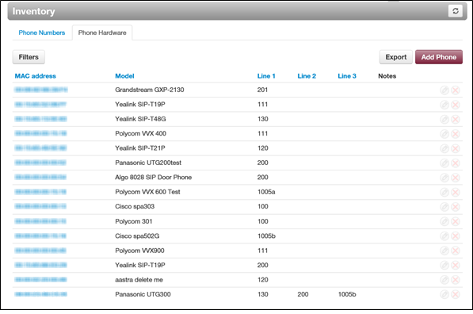

Filtering Phone Hardware
Using the Filter button, you can filter phone hardware and view only the phones of interest to you.
- From the Phone Hardware tab, click the Filters button. The Phone Hardware Filters pop-up window appears.

- Complete the fields (see Table ‎10-2).
- Click Set Filters. The Phone Hardware tab shows only the phones that match your criteria. If no phones match your criteria, a message informs you that there are no matches to your filter.
Table ‎10-2.Phone Filter Settings
Setting | Description
MAC Address | Enter all or part of the MAC address of the phones you want to view.
Make and Model | Select the make and model of the phones you want to view,
Notes | Enter optional notes about this phone filter.

Adding Phones
To add phones:
- From the Phone Hardware tab, click the Add Phone button. The Add Phone pop-up window appears, with the Basic tab displayed.

- Complete the fields in the Basic tab (see Table ‎10-3). The fields that appear are based on the make and model of the telephone selected.
- Click Advanced, and then complete the fields in the tab (see Table ‎10-4). The fields that appear are based on the make and model of the telephone selected.
- Click Save.
Table ‎10-3.Basic Phone Settings
Setting | Description
Model | Adding a phone: enter the telephone’s make and model. The remaining fields that appear in this window depend on the make and model selected.  Editing a phone: read-only field that shows the phone model.
MAC Address | Adding a phone: enter the telephone’s MAC address.  Editing a phone: read-only field that shows the phone’s MAC address.
Line | If your phone make and model have one or more lines, enter them in these fields. The lines available for selection appear if the Add Phone Extension check box is checked when adding a user (see Table ‎4-1 on page ).
Notes | Enter optional notes about this phone.

Table ‎10-4.Advanced Phone Settings
Setting | Description
Directory | If this setting is available for your make and model of phone, select a directory for this phone.
Preferred Server | If this setting is available for your make and model of phone, select the preferred server you want to associate with this phone.
Transport Method | Select a transport method for the phone. Choices are:  - UDP  - TCP  - TLS

Editing Phones
To edit phones:
- From the Phone Hardware tab, either:
- Click a MAC address
OR
- Hover over a phone, and then click the icon at the far right of the Phone Numbers tab. For example:

…click this icon
Click a MAC address or…

Either step displays the Edit pop-up window. For example:
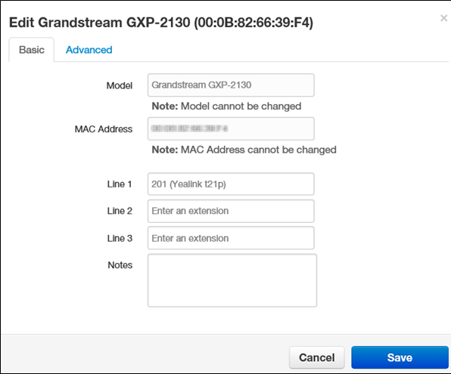

- Complete the fields in the Basic and Advanced tabs (see Table ‎10-3 on page and Table ‎10-4 on page ).
- Click Save.

Exporting Phone Hardware Information
You can export phone hardware information in CSV format, and then open the information in Microsoft Excel for further manipulation.
- From the Phone Hardware tab, click the Export button.
- When prompted, click Save.

Viewing Call History
Topics: |  | Call history allows you to review, filter, and export call logs for greater analysis.
- Displaying the Call History Page (see page )
- Filtering Call History (see page )
- Exporting Call History (see page )

Displaying the Call History Page
All call history tasks are performed from the Call History page. To display this page, click the Call History icon on the menu bar:
The following figure shows an example of the Call History page. The button at the top-right side of the page refreshes the information on the page.
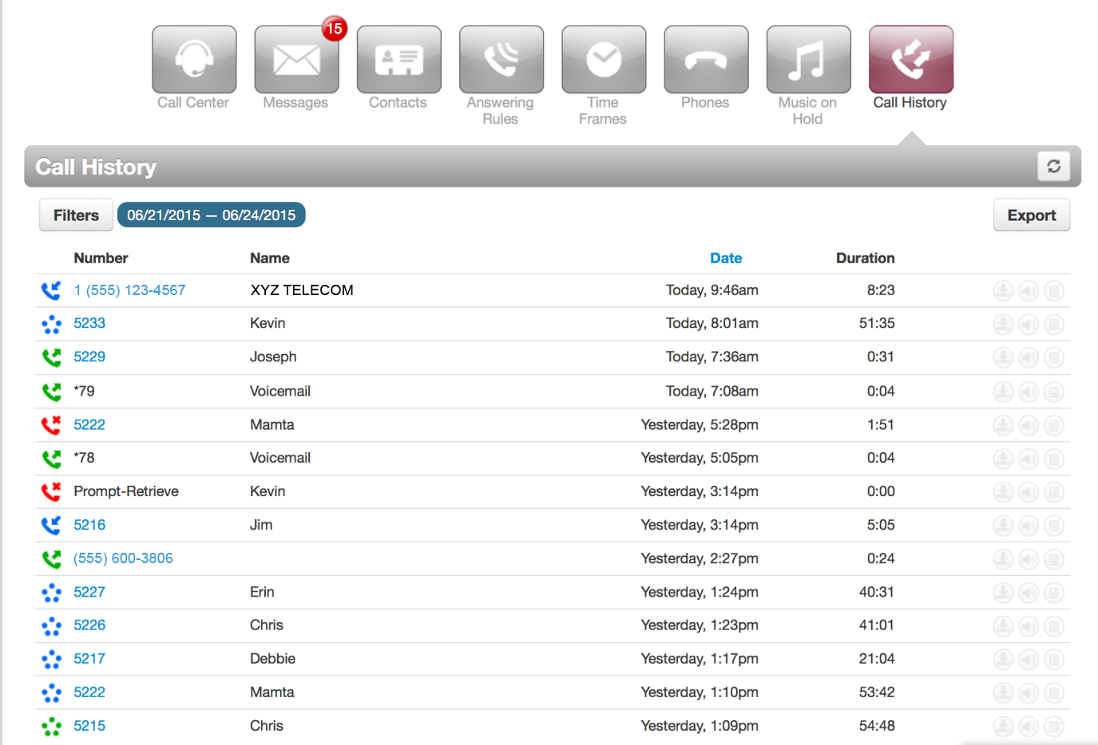

Filtering Call History
Using the Filter button, you can filter your call history and view only the events of interest to you.
- From the Call History page, click the Filters button. The Call History Filters pop-up window appears.

- Complete the fields (see Table ‎11-1).
- Click Set Filters. The Call History page shows only the events that match your criteria. If no events match your criteria, a message informs you that there are no matches to your filter.

Table ‎11-1.Call History Filter Settings
Setting | Description
Date Range | Select the From and To dates for the events you want to view. The maximum From-To range is 31 days.
User | Enter the name or extension you want to view.
Caller Number | Enter the caller number you want to view.
Dialed Number | Enter the dialed number you want to view.
Call Type | Enter the type of call you want to view. Choices are:  - Inbound  - Outbound  - Missed

Exporting Call History
You can export the call history in CSV format, and then open the information in Microsoft Excel for further manipulation.
- From the Call History page, click the Export button.
- When prompted, click Save.

Taking a Phone Home
Topics: |  | Depending on your office’s network configuration, you may be able to use your phone at home.
- Installing a Phone at Home (page )
- Troubleshooting a Remote Phone (page )

Installing a Phone at Home
To install the phone at home, you need an Ethernet cable and an AC power supply.
- Plug either end of the Ethernet cable into the phone’s LAN jack.
- Connect the other end of the cable to your home router or switch.
- Connect the supplied the AC adapter to the phone and to a working AC outlet. The phone is now ready for use.
Note: Your provider cannot guarantee call quality or reliability with phones not on the provider’s data network. In addition, E911 services might not work properly when removing a phone from the office.

Troubleshooting a Remote Phone
In the unlikely event you encounter a problem using the phone at home, consider the following troubleshooting suggestions.
Problem | Corrective Action
Phone can make a call but lacks audio or cannot receive calls. | There might be a problem with your home network. Ensure that your network does not have double Network Address Translation (NAT) or SIP Application Layer Gateway (ALG) disabled on the router. Your provider cannot reconfigure home network; however, your provider will provide technical assistance to your IT staff or vendor.
Your home router is in a different room from the phone, and Ethernet wiring isn’t available between the rooms. | Consider using a Home Plug Powerline solution. Your provider does not provide or support Home Plug systems, but such solutions are available from office supply and electronics stores.
Phone does not work at all. | Contact your provider for technical support. Before calling, have the phone’s MAC address ready.
Phone can make and receive calls but call quality or reliability is poor. | - For connecting your phone/softphone, use Ethernet instead of Wi-Fi.  - Check the quality of your internet connection at http://myspeed.visualware.com. If your Mean Opinion Score (MOS) is below 4, your Internet connection lacks the speed or quality to support an IP phone.  - Your router may be able to prioritize SIP (IP Phone) traffic. Have your IT staff or vendor configure the Quality of Service on your router.  Your provider cannot guarantee call quality or reliability with phones not on the provider’s data network.

            - Glossary
Term | Definition
Application Layer Gateway | A router component that theoretically helps with NAT traversal. In reality, phones can traverse NAT, so ALGs should be disabled.
Answering rule | A rule that specifies how to handle calls for a time frame.
Auto attendant | A feature that transfers calls to the appropriate destination (an extension, voice mail, or recording, for example) without human intervention, by prompting callers to press buttons on their phone keypads.
Call forwarding | A ParagonVoIP WEB Centrex feature that allows you to forward or redirect incoming calls to an alternate number.
Call queue | A call queue allows you to put callers in a waiting line until a person (a.k.a. agent) is available to help them. While in queued callers will listen to Music on Hold and, depending on the configuration, may have options to leave the queue.
Call screening | Prompts callers to say their name, and then lets you screen the call before accepting it.
Conference bridge | Allows a group of people to participate in the same phone call by dialing in using their own phone.
Dial-by-name directory | An auto attendant feature that allows callers to contact employees by knowing their name. The directory is set up by your company and can include the first or last name of all employees. When the caller specifies the first or last name of a person they are trying to reach, the directory confirms the name and connects the caller to that person automatically.
Dialing permission | Defines the types of calls a user can and cannot make. For example, a dialing permission might prevent a user from dialing international calls.
Direct Inward Dial | A service where each user can have a dedicated phone number to reach them, bypassing the auto attendant or receptionist.
Do Not Disturb | The ability of the ParagonVoIP WEB Centrex phone to ignore any incoming calls.
E911 | Enhanced 911. A system used in North America that provides emergency service on cellular and Internet voice calls.
Ethernet | A family of networking technologies for LANs.
Extension | A numerical way to dial a user on your system from a phone (e.g., Bob Smith is extension 111).
Handset | A device that a user holds to the ear to hear the audio sound through a phone. Handsets usually include the phone's transmitter (microphone), which is positioned close to the mouth. A handset is also sometimes used to refer to the entire phone.
IP phone | A telephone handset designed for a VoIP phone system. Instead of being connected to traditional phone lines, IP phones have ports to connect to a LAN.
LAN | Local-area network. A group of computers and other devices that share a common communications line. These devices often share a server and are located within a small geographic area.
Log | A file that records events that occur in the ParagonVoIP WEB Centrex system.
MAC address | Media Access Control address. A unique identifier assigned to network interfaces for communications on the physical network.
Mean Opinion Score | A test that used in telephony networks to estimate the human user's view of the quality of the network.
Music on Hold | Music or announcements that callers listen to while on hold.
Network Address Translation | Converts your private LAN IP address to a public IP address, allowing traffic to go out to the Internet and route back to the correct device on your LAN.
Offnet | Off-network calls. Calls placed to a network other than your network.
PBX | Private Branch Exchange. Also known as a phone system. A PBX provides an expanded range of voice services such as phone extensions; call forwarding, paging, voicemail for each user.
Server | A computer that is dedicated to a particular purpose. Typically, a server provides information to client computers upon request. For example, a voicemail server manages all voicemail-related functions, and client computers access that server to retrieve or send voicemail.
Simultaneous ring | Allows multiple phones to ring at the same time. For example, you can configure the system so that when someone calls an office number, a desk phone and a mobile phone can ring simultaneously.
SIP | Session Initiation Protocol. The standard protocol for Voice Over IP communications. For example when making a call from one extension to another on a VoIP phone system, SIP sets up the call and creates the connection between the two extensions.
Softphone | IP telephony software that allows users to send and receive calls from non-dedicated hardware, such as a PC or Smartphone. It is typically used with a headset and microphone.
Time frame | In the ParagonVoIP WEB Centrex system, a configuration that is applied to a specific period of time, such as a holiday. A time frame does not go into effect until you apply it to an answering rule or auto attendant greeting. When the time frames are applied, the first matching time frame becomes active.
Trunk | A communications channel between two points.
Uniform Resource Locator | The address of a specific site on the Internet. A URL cannot have spaces or certain other characters, and uses forward slashes to denote different directories. For example, http://web.mit.edu/.
Voicemail | A feature that allows callers to deliver voice information using an ordinary telephone and allows the system to process those transactions.
Wi-Fi | A popular wireless networking technology that uses radio waves to provide wireless high-speed Internet and network connections.

Index
A
Active calls, 14
Adding
answering rules, 26
auto attendants, 50
call queues, 61
conferences, 42
Music on Hold, 67
Music On Hold files, 86
phones, 97
time frames, 79
users, 19
Adjusting Music On Hold settings, 89
Agents, 68
Allowing calls, 25
Answering rules
adding, 26
changing, 28
configuring, 24
deleting, 31
editing, 30
Associating phones with a user, 36
Auto attendants
adding, 50
best practices, 57
deleting, 57
editing, 55
recording intro greetings, 52
recording menu prompts, 52
B
Best practices, auto attendant, 57
Blocking
callers, 13
calls, 25
C
Call forwarding, 13
Call graphs, 15
Call history
exporting, 105
filtering, 104
Call History page, 103
Call queues
adding, 61
agents, 68
deleting, 67
editing, 65
Call Queues page, 60
Callers, blocking, 13
Calls, active, 14
Calls, allowing or blocking, 25
Changing
answering rules, 28
open hours, 12
order of Music On Hold files, 87
Conferences
adding, 42
deleting, 46
editing, 44
joining, 46
statistics, 47
Conferences page, 41, 49
Configuring
phones, 35
user answering rules, 24
user profiles, 22
user voice mail, 31
Conventions in this document, v
D
Deleting
answering rules, 31
auto attendants, 57
call queues, 67
conferences, 46
Music On Hold files, 89
phones, 38
time frames, 82
users, 39
Displaying
Call History page, 103
Call Queues page, 60
Conferences page, 41, 49
Inventory page, 92
Music On Hold page, 84
Time Frames page, 74
Users page, 17
Document conventions, v
E
Editing
answering rules, 30
auto attendants, 55
call queues, 65
conferences, 44
Music On Hold files, 88
phone numbers, 94
phones, 37, 100
time frames, 81
users, 21
Employees, replacing, 11
Exporting
call history, 105
phone hardware information, 101
phone numbers, 95
F
Filtering
call history, 104
phone hardware, 96
phone numbers, 93
G
Glossary, 108
Graphs, 15
H
Holidays, 12
Hours, changing, 12
I
Importing users, 38
Installing a phone at home, 107
Intro greetings, recording, 52
Inventory page, 92
J
Joining a conference, 46
L
Logging in to the Web Portal, 7
M
Menu prompts, recording, 52
Moving a phone, 11
Music on Hold
adding, 67
Music On Hold
adding files, 86
changing file order, 87
deleting files, 89
editing files, 88
page, 84
settings, 89
O
Open hours, 12
P
Password reset, 11
Phone
installing at home, 107
troubleshooting, 107
Phone numbers
editing, 94
exporting, 95
filtering, 93
Phone, moving, 11
Phones
adding, 97
associating with a user, 36
configuring, 35
deleting, 38
editing, 37, 100
exporting hardware information, 101
filtering, 96
R
Recording
intro greetings, 52
menu prompts, 52
Replacing employees, 11
Resetting a password, 11
S
Setting
call forwarding, 13
new holidays, 12
Statistics
conference, 47
panel, 15
T
Time frames
adding, 79
deleting, 82
editing, 81
viewing begin and end dates, 82
Time Frames page, 74
Troubleshooting a remote phone, 107
U
User profiles, configuring, 22
Users
adding, 19
deleting, 39
editing, 21
importing, 38
Users page, 17
V
Viewing begin and end dates, 82
Voice mail, configuring, 31
W
Web portal log in, 7

ParagonVoIP
1445 E New York Ave
Deland, FL 32724
Phone: (386) 860-0005
www.ParagonVoIP.com

ParagonVoIP has made a good faith effort to ensure the accuracy of the information in this document and disclaims the implied warranties of merchantability and fitness for a particular purpose and makes no express warranties, except as may be stated in its written agreement with and for its customers.
ParagonVoIP shall not be held liable to anyone for any indirect, special or consequential damages due to omissions or errors. The information and specifications in this document are subject to change without notice.

Copyright © 2015. All Rights Reserved.
All trademarks and registered trademarks are the property of their respective owners.
ParagonVoIP WEB Centrex Administrator's Guide
July 2015
Document version: Version 2

